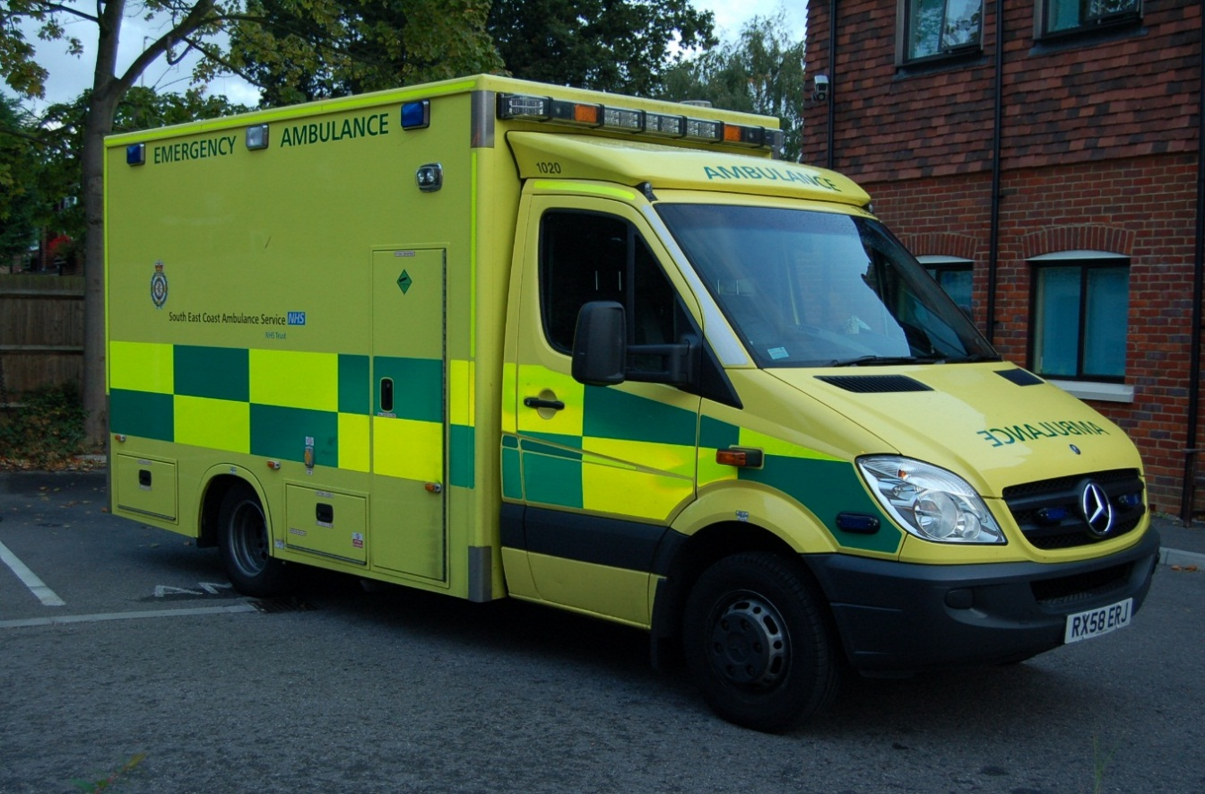

ASPH & RSCH NHS Foundation Trusts
in partnership with
South East Coast Ambulance Service

“Simulation Tricky Trips” (STricT)

Critical Care Transfer Training

COURSE BEST PRACTICE REFERENCE BOOKLET

In association with South East Coast Critical Care Network

Note from the Editor:

The STricT Course has been developed by a team of individuals who have passion and enthusiasm for training and transfers. The team are experienced and very knowledgeable in the areas of Transfer of Critically Ill Adults and in providing simulation based training. Please allow me to thank each and every member of the STricT Course Faculty and Course Development team for their continued hard work and support they provide to ensure this course and materials are the most up-to-date, as the majority of the team do this in their own time.
This booklet and the Multiple Choice Questions that will be tested on the course, have been recently updated by the following members of the STricT Team.
Dr K Somasundaram Consultant Critical Care ASPH
Dr A Kuttler Consultant Anaesthetist ASPH
Dr M MacGregor Consultant Anaesthetist ASPH
Mr B Pasquier Senior Operating Department Practitioner ASPH

In addition, I would like to acknowledge the significant contributions of the following team members in development, administration and ongoing support for this course:

Dr M Bossy Joint Course Director & Consultant Critical Care RSCH
Dr R Savine Joint Course Director & Consultant Critical Care RSCH
Mrs Janet Wright Simulation Manager ASPH
Dr S Sen Simulation Fellow ASPH
Dr J Cooper Consultant Critical Care ASPH
Sister I Johnson Critical Care Outreach Lead ASPH
Dr S Lomax Consultant Anaesthetist & Simulation Lead RSCH
Dr J Doyle Critical Care & Anaesthetics Fellow RSCH

Thank you and I hope you find this manual useful and enjoy the course!

Dr Nikunj Shah
Course Director & Consultant Critical Care ASPH

Thank you to our course sponsors:

CONTENTS
Chapter: | Page:
- Introduction | 4
- The Challenge | 7
- The National Best Practice Guidance for the  Transfer of the Critically Ill Adult | 7
- Physiology & Physics of Transfers | 10
- Getting the Patient Ready | 11
- Communication & Organisation | 17
- The Journey | 19
- What To Do When Things Go Wrong | 22
- Specialist Transfers | 23
- References | 26
Appendices:
Appendix 1: SECCCN Operational Flowchart | 27
Appendix 2: SECCCN Transfer Protocol | 28
Appendix 3: SECCCN Intra-aortic Balloon Transfer Protocol | 29
Appendix 4: Trauma Network Head Injury Protocol | 30
Appendix 5: Trauma Network Spinal Injury Pathway | 31
Appendix 6: Trauma Network Adult Major Trauma Decision Tree | 32
Appendix 7: Trauma Network Secondary Transfer Protocol for Major Trauma | 33
Appendix 8: SECCCN Joint Transfer Protocol with Independent Sector Hospitals | 34

- INTRODUCTION

Surrey Wide Critical Care Network
The Surrey Wide Critical Care Network (SWCCN) was formed in March 2001 in response to ‘Comprehensive Critical Care’ (DOH 2000). The ultimate aims of the Network are:
• To improve and maintain access to critical care services.
• To ensure the provision of high quality critical care services within the Network.

The Network is establishing the gold standards by which critical care should be delivered by sharing best practice and developing joint protocols, ultimately improving both patient care and the patient / relative experience. The Network Forums, including the Transfer Group, provide an excellent framework for the spread of best practice and local clinical governance into the wider critical care and acute care community.

The SWCCN has also developed a transfer policy which provides the framework within which all critical care transfers, both from acute providers and the independent sector, must operate. The SWCCN now feeds into a larger network, the South East Coast Critical Care Network.

South East Coast Critical Care Network (SECCCN)
The South East Coast Critical Care Network (SECCCN) was established in April 2013 as a result of the merger between Kent and Medway; Surrey and Sussex Critical Care Networks. The role of the network is to enable Critical Care Services to work together to promote the highest quality of care for people in the South East of England. Critical Care is a vital hospital service for people with life threatening injuries and illnesses. The Intensive Care Unit is where the sickest patients in hospitals are treated. Critical Care staff also provide support to ward areas to ensure the early recognition and response to acutely ill patients wherever they are in the hospital. The SECCCN will promote clinical engagement and collaboration across the South East Coast region to ensure the delivery of safe and effective services for critically ill patients throughout the patient pathway. It will provide guidance on service standards to ensure equity of the care patients and their families and loved ones receive. Critical care pathways will be audited and best practice identified to serve as a benchmark for service improvement. The SECCCN provides a link between commissioners and providers of critical care to promote integration and coordination of services. The SECCCN will assist commissioners and providers to coordinate resources to secure the best outcomes for patients. Critical Care activity will be monitored across the region to assist capacity planning and to forecast demand, to ensure that supply and demand of Critical Care services are matched even at times of peak activity. Members of the SECCCN will work collaboratively to share learning, experience, knowledge and skills; to enable staff to have the skills and confidence to develop Critical Care services in line with initiatives and progress in medical practice and to meet the expectations of commissioners and the public.

Surrey Network Trusts and Hospitals
Acute Trusts
- Ashford & St. Peter’s Hospitals NHS Foundation Trust (St. Peter’s Hospital, Chertsey)
- Frimley Park Hospital Foundation Trust (Camberley)
- Royal Surrey County Hospital NHS Foundation Trust (Guildford)
- Surrey & Sussex Healthcare NHS Trust (East Surrey Hospital, Redhill)

Independent Sector Hospitals
- Spire Clare Park
- Spire Gatwick Park
- Woking Nuffield
- Guildford Nuffield
- BMI Runnymede
- BMI Mount Alvernia
- Ramsay North Downs

South West London & Surrey Trauma Network (SWLSTN)
The Network works closely with the SWLSTN which has the following structure:

Major Trauma Centre
- St. George’s
Trauma Units
- Croydon University Hospital
- St. Helier Hospital
- Kingston Hospital
- Frimley Park Hospital
- Royal Surrey County Hospital
- St. Peter’s Hospital

As at July 2012, East Surrey is currently working towards meeting the criteria.

The trauma system requires patients to be transferred direct from the pre-hospital setting scene of incident to the MTC. This is known as primary bypass and is activated by the triage decision tree (Appendix 6). This is now in place across Surrey so the TUs should see less major trauma and decision tree positive patients. Patients may be taken to the nearest TU if outside the 45 minute isochrome from the MTC or advanced airway management is required. These patients should then have rapid onward transfer to the MTC utilising the secondary transfer protocol (Appendix 7).

“Tricky Trips” Transfer Training
Critical care patient transfers are an integral component of the Network critical care service although stringent efforts are made to reduce/negate non-clinical transfers due to lack of critical care beds. Although specific training is not a required aspect of multi professional training it is considered to be highly desirable in order to maintain both patient and staff safety during the transfer. The literature recommends that staff should be competent in the transfer of patients and that staff engaged in transfer should be appropriately trained although transfer training courses specific to critical care are both scarce and costly with no agreed standardised national format.

The most recent Intensive Care Society Transfer Guidelines (2011) clearly state that critical care networks should be responsible for:
- The coordination and development of transfer services within defined geographical areas.
- Reviewing the potential for dedicated transfer teams.
- Considering potential for dedicated transfer teams.
- Develop referral pathways, transfer protocols and quality assurance programmes

The Network commenced its initial transfer training programme, “Tricky Trips”, in 2003, which has since been developed by the transfer group into the current multi-disciplinary study day looking at best practice for the inter-hospital and inter-departmental transport of critically ill patients. This one day study day is delivered by the dedicated multi-professional network faculty comprising critical care and ambulance staff who all possess considerable experience in transferring the critically ill. To enhance and make the training realistic the use of simulation scenarios has been developed.

The aims of the transfer training are to provide an overview of the following:
- Best practice guidelines and policies both national and local.
- Local documentation i.e. Network transfer audit form.
- Preparing and packaging the patient for the journey.
- Equipment required and its use.
- During the journey and dealing with potential problems.
- Specialist transfers and monitoring differences.
- Communication and organisation.
- Orientation to the back of the ambulance.

The “Tricky Trips” training day is designed for local network use as it contains detail on local policies, protocols, equipment and documentation. The network training days are open to all multi-professional staff within the network hospitals, both NHS and independent sector.

The ‘STricT’ Course uses simulation based training to ensure appropriate delivery of the aims listed above. The use of simulation will in addition allow candidates to develop and acknowledge some of the non-technical skills required for critical care trensfers.

Best Practice Booklet
The purpose of this best practice booklet is to identify and summarise the key points needed to ensure safety during transfers. This will negate the need for extensive handouts on the training days and will allow all staff to have a permanent quick reference guide.

The following pages contain information, photographs and diagrams on the key issues contained within the programme.

Course Assessments
To complete the course, candidates must read this booklet, attend the full days’ course and on the day of the course pass a written assessment.

- THE CHALLENGE

- In 1997 in the UK approximately 11,000 critically ill patients were transferred from one hospital to another for clinical and non-clinical reasons.
- For the period April 2008 – March 2009 there were 291 transfers within the Surrey Wide critical care network (approx 24 per month).
- Previously inadequate equipment and resources.
- Often inadequately trained/experienced escorts.
- Hostile environment.
- Uncontrolled temperatures – rain, snow, wind chill.
- Acceleration/deceleration forces.
- The need for transfers is likely to increase with the centralisation of specialist services.

- THE NATIONAL BEST PRACTICE GUIDANCE FOR THE TRASNFER OF THE CRITICALLY ILL ADULT

Intensive Care Society
1997: Guidelines for the transport of the critically ill adult.
2002: Guidelines for the transport of the critically ill adult (updated).
2011: Guidelines for the transport of the critically ill adult (3rd Edition 2011)
- Greater emphasis on the transfer of level 2 critically ill patients
- Introduces a framework for risk assessment prior to transfer to ensure that staff with the appropriate competencies accompany the patient
- Organisation within networks
- Recommends lead consultant for critical care transfers identified within each trust
- Consideration of dedicated transport teams
- Agree a framework for prioritisation of transfers
- All staff must receive appropriate training
- All hospitals must have access to a CEN compliant transfer trolley

Department of Health 2000: Comprehensive Critical Care
- Recommend that ICS guidelines are used to develop local policies.
- Recommend that staff engaged in transfer are appropriately trained.

The Association of Anaesthetists of Great Britain and Ireland (2009): Safety Guideline on Inter-hospital Transfer
- The need for transfers is likely to increase.
- Networks should be responsible for standards of protocols and documentation.
- All personnel undertaking transfers should have the appropriate competencies, qualifications and experience, which should include attendance at a suitable transfer course.
- Details of every transfer must be recorded and subject to regular audit and review.

Complications
- Every transfer is a risk.
- Cardiac e.g. hypotension, hypertension, arrhythmias.
- Pulmonary e.g. aspiration, hypoxaemia.
- Equipment e.g. electrical power loss, oxygen supply loss, displacement of tubes.
- All incidents are monitored and audited by the network.

Mode of Transport
Selection of transport mode should take into account the following:
- The nature of the illness (e.g. spinal injuries).
- Urgency of the transfer.
- Availability of transport.
- Mobilisation times.
- Geographical factors and distances (e.g. highlands and islands of Scotland).
- Traffic and weather conditions.
- Cost. i.e. in relation to price of helicopter and fixed wing transfers.

Documentation
- Standards apply to inter-departmental as well as inter-hospital transfers.
- Completion of Surrey Wide Critical Care Network transfer audit form (below) is essential.
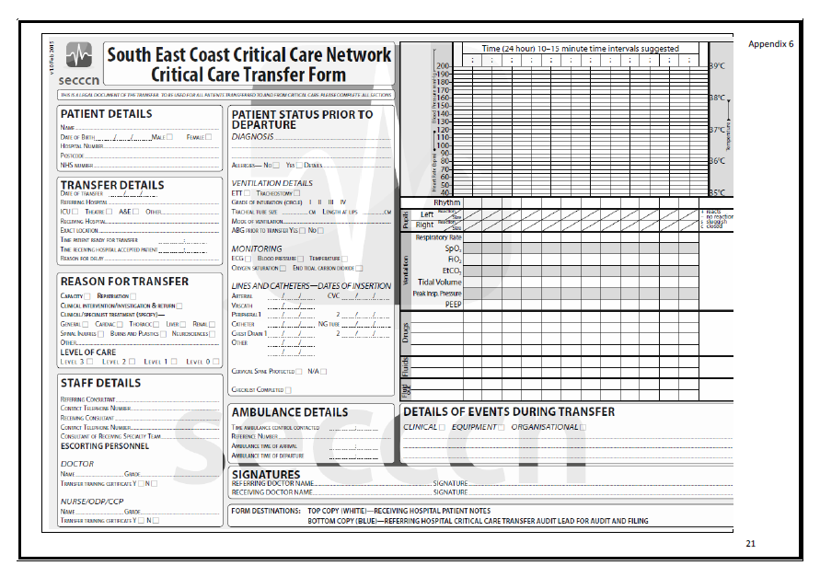

Equipment
- Portable ventilator.
- Portable monitor.
- Electrical inverter/spare batteries.
- Portable suction.
- Transfer bags, drugs etc.
- Vacuum mattress.
- Stretcher table for equipment.
- Spare CD size oxygen cylinder.
- Dedicated transfer trolley ideally.

Accompanying Personnel
- Critically ill patients should be accompanied by at least 2 suitably experienced escorts, one of which should be a medical practitioner and the other a nurse, ODP or other e.g. paramedic.
- Physician must have airway competence and ATLS/ALS awareness.
- All must be familiar with equipment and intensive care procedures.

Insurance
- Insurance to cover staff & patients are provided by own organisation and professional bodies.

Decision Process for Transfer
- The decision to transfer must be made at consultant level with direct communication with receiving hospital.
- Responsibility stays with referring hospital until handover.

Standards
Preparation
- Transfer team must familiarise themselves with patient and case history.
- Patients should be meticulously resuscitated and stabilised prior to transfer.
- Seek advice from receiving unit on specialist actions e.g. neurosurgical.
- Packaging e.g. endotracheal tube, intravenous infusions, spine care.
- Departure checklist.
- Network transfer audit form.
Education & Training
- All staff involved in transfer have a duty to ensure they are trained.
- “Tricky Trips” first and then STaR as required.

Quality Assurance
- Network transfer audit form.
- Monthly and annual transfer audit by network.
- Local database maintained.
- Critical incident reporting.

Transfer Team Return
- SECamb does not have the responsibility to return transfer team but will make all attempts to do so.
- Staff should take money and a mobile phone in case they have to make their own way back (e.g. taxi).
- Staff should be aware of own Trust protocol for the return journey.
- Crew may be needed for emergency on return journey.
- Crew will leave escorts at place of safety if unable to complete return journey.

- PHYSIOLOGY & PHYSICS OF TRANSFERS
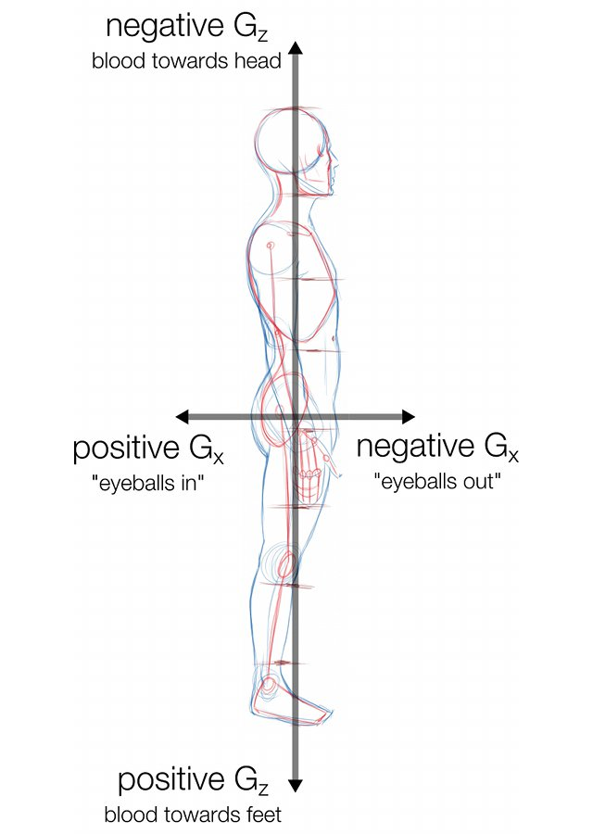
- Newton’s third law states that ‘for every action there is an equal and opposite reaction’.

- Acceleration can be positive or negative, linear or angular.
When a body is accelerated due to the action of an external force, it will experience an equal and opposite force termed ‘inertia’. This inertial force may be experienced in the x-axis (antero-posterior), y-axis (lateral), z-axis (cephalo-caudal) or in any combination of the above. The physiological effects of this inertia result in the displacement of solid organs and (more importantly) the fluid compartments, particularly blood. The effects of displacement will depend upon the rate, magnitude (measured in numbers of gravities or G’s) and direction of acceleration (axis).

For example;
If you accelerate towards your head (Ambulance accelerating) – your blood will move towards your feet (like an elevator rapidly rising). This will result in decreased cardiac preload, decreased cardiac output and hypotension. This inevitably reduces cerebral perfusion, with the subsequent risk of seizures and ischaemic strokes. In normal health the body has mechanisms to counteract this (Baroreceptor reflex and vasoconstriction). In critical illness these reflexes may be abolished or reduced, secondary to the illness or artificially by drug therapy. Hence the hypotension may be profound. Some of the risk can be mitigated by ensuring the patient is optimally fluid filled. Other techniques that have been used include the use of pneumatic anti-shock suits or performance of straight leg raising during acceleration.
If you decelerate towards your feet (Ambulance braking) – your blood (and stomach contents) will move towards your head (like an elevator falling). This will result in increased preload, right atrial distention and increased cardiac output. This makes patient more prone to cardiac arrhythmias, pulmonary oedema and event cardiac arrest. In normal health the body can compensate by increasing the strength of contraction, baroreceptor reflexes causing bradycardia, and increased renal clearance of fluids. Also note that this direction of acceleration will also increase intra-cranial pressure.
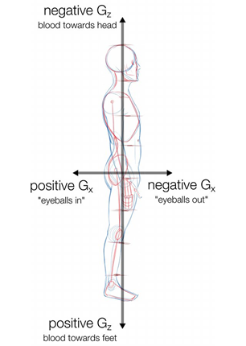
The most exaggerated effects are seen when bodies are accelerated in the Z-axis.
Other physiological effects to consider during the transfer are the effects of:
Temperature:
Vibration
ENSURE THE PATIENT IS HAEMODYNAMICALLY OPTIMISED PRIOR TO TRANSFER TO MINIMISE THE RISKS FROM ACCELERATION & DECELERATION
Noise
Atmospheric pressure changes

- GETTING THE PATIENT READY

ALWAYS ENSURE YOU HAVE A BACK-UP PLAN FOR EACH SYSTEM

Preparation – Practicalities
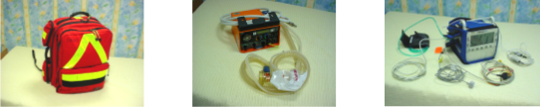
- Get to know the transfer equipment – before you need to use it!

- Escort personnel should familiarise themselves with the patient.
  - History
  - Physical examination – avoid surprises!
  - Investigations (bloods especially Hb, glucose, ABGs, x-rays, CT scans)
  - Get blood products for journey if required.

- Thorough resuscitation, stabilisation and preparation before departure is mandatory EXCEPT with TIME CRITICAL transfers
- Start transfer documentation early before departure using the network transfer audit form.

A Systematic Approach
- Airway / sufficient oxygen supply
- Breathing / ventilation
- Circulation / monitoring
- Disability/AVPU/sedation
- Exposure/ temperature/whole look at patient and patient coverings and vacuum mattress

- In the chaos of a transfer situation, it is all too easy to forget to do things.
- Prepare inadequately and expose yourself, your colleagues and your patient to unnecessary risk.
- The ABC approach guides you to be systematic and thorough when preparing for a transfer.
- Whenever you might be confused or overwhelmed, use the ABC approach to order your thoughts.
- The personnel who undertake the transfer should be in control of preparing the patient and should not embark on the journey until they are satisfied that they are ready to do so safely.
- You should ensure you have a back-up plan for the potential of equipment failure where practicably possible.

Airway
- Airway
  - Secure the airway – where doubt exists about maintaining an airway and/or providing adequate oxygenation during transit, the patient should be intubated.
  - Ventilator tubing must be secured to prevent accidental extubation – do not secure tubes to pillows.
  - Resources for re-intubation and basic airway management during the journey should be easily to hand.
  - Appropriate drugs and flushes should be readily available.
  - IV routes should be visible at all times, easily accessed and clearly labelled.
  - Insert NG tube and place on free drainage – reduces risk of aspiration – remember the effects of rapid deceleration on stomach contents.

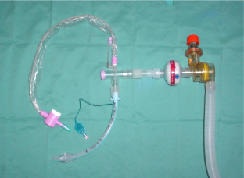
- Suction
  - Ensure adequate suction (either via ambulance or ICU kit).
  - Selection of suction catheters that fit.
  - Consider closed suction system – reduces ‘fiddle’ factor and maintains PEEP for longer.

Breathing
- Ventilators
  - Portable ventilators (e.g. Oxylog™ Pneupac ParaPac™ Carina LTV™)
  - Basic ventilation modes on older vents (CMV, SIMV) +/- PEEP.

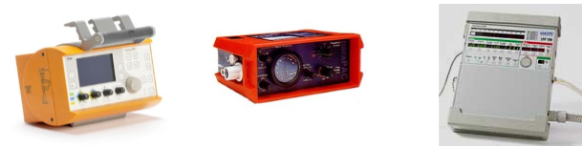
Oxylog 3000 Pneupac ParaPac Carina LTV

Always keep an AmbuBag with you at all times.

The following should be charted during the journey:
- Mode of ventilation
- Rate
- Tidal volume
- Minute volume
- Inspired oxygen
- Peak airway pressure
- Oxygen saturation
- End tidal (ET) CO₂
- Inspired oxygen concentration – often limited to 60% or 100%

- Ensure ET CO₂ probe is positioned uppermost in circuit.

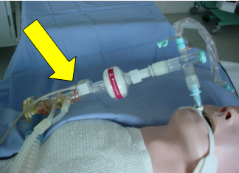

Pneumothoraces
- If a pneumothorax is present, chest drains should be inserted prior to departure:
  - Portable chest drains can be used.
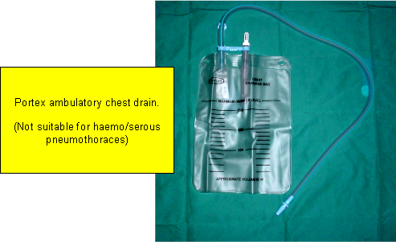

  - Chest drains should not be clamped.

Circulation

Venous Access
- Secure vascular access is mandatory
- Two wide bore cannulae (peripheral or Central)
  - Three way taps with self sealing bungs – e.g. Bionector
- Hypovolaemic patients tolerate movement poorly and may require volume loading before departure.
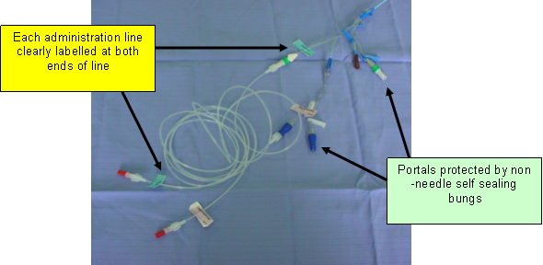
- Patients should not be moved until haemodynamically stable +/- inotropes (Unless Time Critical Transfer).
Arterial Line
- Arterial line desirable – ABGs before departing, invasive monitoring and CLEARLY LABELLED.
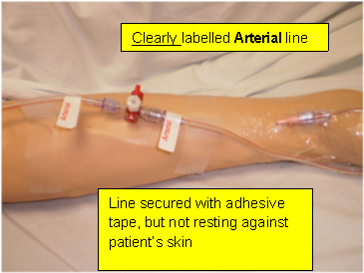

Monitoring
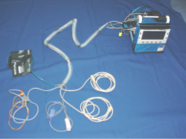
- Minimum: ECG, NIBP, oxygen saturation, ETCO₂, temperature.
- However NIBP is sensitive to motion and drains battery.
- Invasive pressure monitoring (especially arterial) provides more accurate and real time information and ‘…. Should normally be used’.
- Although the NIBP should not be used frequently during the journey, the cuff and hose should be placed in situ in case the arterial line falls out.
- Ideally the NIBP cuff should not be placed on the arm with the arterial line or sats probe – if the cuff is inflated it will cause a sats alarm and an invasive BP alarm.
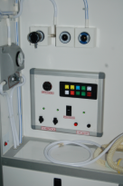
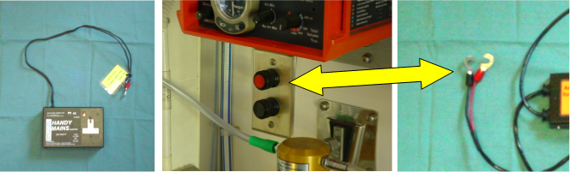
- NIBP should be taken prior to transfer using the NIBP on transfer monitor ensuring that the reading is verified using the invasive pressure reading.
Power Supplies
- Power for equipment is available using electrical inverters which are placed between the ambulance supply and the equipment.
- The most recent ambulance specification requires the addition of 240 and 12 volt power supplies; these may be found and can be used.

Disability
- Ensure adequate assessment of AVPU/GCS. If patient sedated, ensure adequate supplies. Consider pre-filling syringes.
- Ensure BM recorded, if relevant.

Exposure
- Ensure patient has been fully examined, ensuring that all drains, catheters and IV cannulaes are secure and functioning as required.
- Ensure patient is secure on stretcher, vacuum mattress or bed.
- Ensure patient is kept at the correct temperature.
  - Protect patient by use of covering i.e. sheet/blanket or mediwrap®

Contacting the Ambulance Service
- Contact EDC only after all decisions to transfer have been made and patient stabilised (if non major trauma transfer)
- Crew are only obliged to wait for 20 minutes after arrival
- Identify responsible individual for contacting the EDC within own hospital
- Enter ambulance reference code and times of contact on transfer form
- If police escort is felt necessary, this must be requested by the consultant responsible whom should liaise with EDC

Packaging’ and Moving the Patient
- Wrap up the patient before the ambulance stretcher/porters arrive – prevents accidents (e.g. the patient’s arms falling over the side of stretcher), confusion and mayhem when the ambulance crew arrive.
- Place lines and circuits where they can be easily accessed during the journey.
- Ensure you maintain the patient’s dignity especially during transfers between departments within the hospital setting.
- Use a patslide™ to move patients between bed and stretcher.

Positioning
- Unless contra-indicated (e.g. spinal injuries, hypotension), patients should be positioned 30° head up (as per ventilator care bundle).
- Reduces the risk of aspiration – especially in presence of rapid deceleration forces when ambulance slows down.
- Reduces movement of the patient up the stretcher.
- Patient should be secured at all times with trolley harness.
- Use a stretcher table where available
- Do not place items of kit on patient.
- Arms/neck with IV access should be exposed and visible.
- Rest of patient should be kept warm – especially when out in the open.

Vacuum Mattress
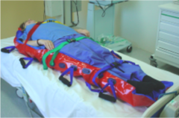
- Where patients are being moved from A&E or ICU to a CT scanner, they should be placed on a vacuum mattress and safely secured regardless of whether they have a spinal injury or not:
  - Reduces the risk of accidents.
  - Facilitates safe movement of patient.
  - Promotes safe management of airway, IV access, monitoring

Preparation – Summary
- Aim to reduce risks to patient and staff.
- Familiarise yourself with the patient prior to transfer.
- Prepare thoroughly:
  - Airway
  - Ventilation
  - IV access
  - Monitoring
- Timely contacting of ambulance service and recording of reference number
- It is not advised or considered safe to wear theatre clogs during a transfer

- COMMUNICATION & ORGANISATION

The SBAR communication tool originated in the US Navy for use on nuclear submarines. It has also been used in the airline industry. Because it assists the transfer of important information in limited time, SBAR has been
adopted by many healthcare organisations across the world.

Consider 5 elements of ISBAR:
- Introduction
- Situation
- Background
- Assessment
- Recommendation

Introduction:
- Identify yourself and the site/unit you are calling from
- Identify the patient by name and the reason for your call

Example
- ‘I am the ODP John Blocks covering the CEPOD list at St Peters hospital. I need blood urgently for the patient by the name of Mr Jack Smith.’

Situation:
- Describe your concern
- Firstly describe specific situation about which you are calling including patients name, current consultant, patients location, code status and vital signs

Example:
- “I have a patient, Mr Jack Smith, a 58 year old man who has a right subdural bleed following a fall. He has a fluctuating GCS, currently 11/15 E3, V3, M5. He is under the care of Mr Jones, in A&E Resus. His other observations currently are pulse 68 regular, BP 170/80, RR 22, Oxygen Sats 98% on 2L oxygen.”

Background:
- Give the patients reason for admission
- Outline significant background medical history including diagnoses, date of admission, procedures undertaken, allergies, drug history and results of relevant investigations.
- Ensure you have all the relevant information to hand including all the patients’ charts.

Example
- “He suffered an unwitnessed collapse at home following feeling unwell this morning and was brought in by ambulance with a GCS of 6/15 and dilated unresponsive right pupil. His CT head was reported as a right subdural haematoma with midline shift. He has received 200mls of 20% Mannitol with recovery of pupillary responses. His current GCS is 11/15. He is on Warfarin for AF and his INR is 2.8. He is also allergic to penicillin.”

Assessment:
- Use ABCDE for describing vital signs and current patients status including system support.
- Give a working diagnosis or a list of differential diagnoses
- Allay your current concerns

Example
A – Airway
“His airway is managed with a size 8 endotracheal tube which has been tied at 22cm, there is also an oral gastric tube in place on free drainage.
B - Breathing
“He is being ventilated with IPPV at a rate of 15bpm and is saturating at 98% on 50% FiO2”.
C – Circulation
“He has an arterial line in his left wrist with an NIBP cuff on his right upper arm. He remains haemodynamically stable. He has a 16g cannula in right forearm which is connected to 1 litre bag of crystalloid. He has a urinary catheter which is draining adequate volumes.”
D – Disability
“He is sedated with Propofol 100mg/hr for anaesthesia and there are no glycaemic issues”
E – Exposure
“His tympanic temperature is 36.1 degrees Celsius and we are keeping him intentionally cool. His pressure area are being cared for by gel pads”

Recommendation
- Explain what you need—be specific about the request and the time frame
- Make suggestions
- Clarify expectations

Example
- “We would like you to accept transfer of this patient under your neuro-surgical care to the Neuro ITU at St Georges Hospital, as a time critical transfer. Please can you confirm this with your Consultant and ring me back within 30 minutes to communicate the response.”

- THE JOURNEY

Safety
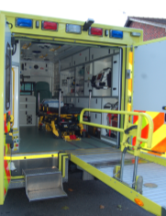
- All journeys carry risk but the aim should be to minimise this wherever possible—patient safety is paramount.
- Plan ahead and prepare for anticipated issues during the journey, e.g.: accessing IV line whilst moving.
- Two attendants to accompany patient—skill mix decided after discussion with senior clinician.
- Communicate clearly and make your needs known e.g.:
  - 0₂ for lift, in CT scanner.
  - Extra escort personnel in ambulance.

Avoiding Catastrophes
- Secure and protect anything and everything that can move:
  - Airway – ET tube and circuit.
  - Breathing – Ventilator and oxygen.
  - Circulation – monitor and IV access + remote access line.
  - Infusion pumps.
  - Urinary catheters.
  - Chest drains.

Prior to Transfer
- On departure, ensure someone calls the receiving unit to inform them that you’re leaving.
- Take a mobile phone with you alongside the numbers of your seniors and those of the receiving unit in case of emergencies or a change of plan.
- The ambulance crew are responsible for getting the patient on to the ambulance.
- Consider running through the departure checklist (next page).

Seating Arrangement in an Ambulance
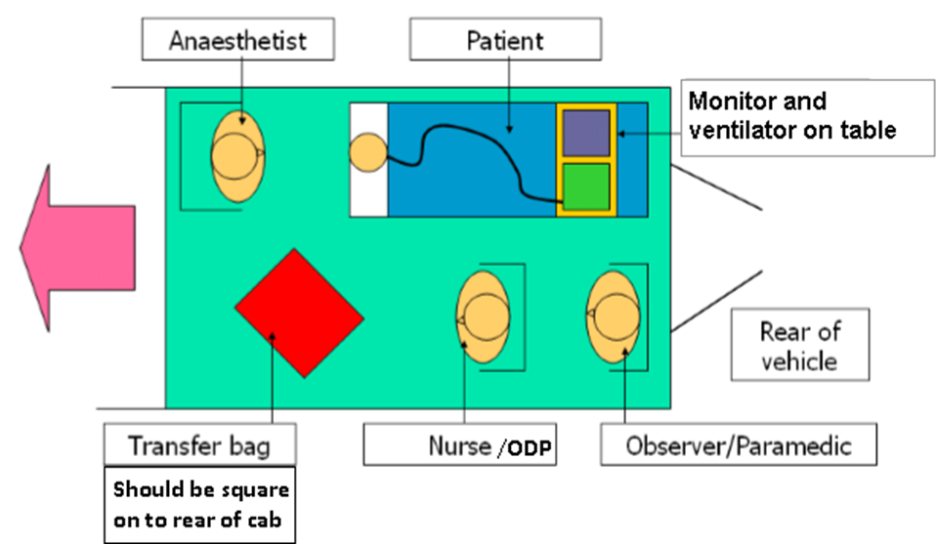
Departure Checklist

The use of checklists to ensure safe practice is becoming increasingly widespread. It is beneficial for the transfer team to run through this prior to departure—not only to make sure that everything is prepared but also as a generalised (de)brief for the incoming ambulance staff and or the staff at the departing site to address any inaccuracies or concerns. The list below is neither exhaustive nor compulsory but should act as a guide for you to shape your own practice.

- Do attendants have adequate competencies, experience, knowledge of case, clothing, insurance?
- Appropriate equipment and drugs?
- Batteries checked?
- Sufficient oxygen?
- Trolley available?
- Ambulance service aware or ready?
- Bed confirmed? Exact location?
- Case notes, X ray films, results, blood collected?
- Transfer chart prepared?
- Portable phone charged?
- Contact numbers known?
- Money or cards for emergencies?
- Estimated time of arrival notified?
- Return arrangements checked?
- Relatives informed?
- Patient stable, fully investigated?
- Monitoring attached and working?
- Drugs, pumps, lines rationalised and secured?
- Adequate sedation?
- Still stable after transfer to mobile equipment?
- Anything missed?

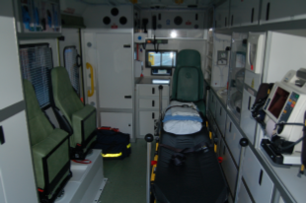

Starting the Journey
- The ambulance / bed should move only when the transfer team members are happy with the arrangements;
    - Ventilator, monitor and infusion pumps securely stowed and easily seen.
    - Trolley and patient are safely secured.
    - Transfer bag is placed in reach.
    - Transfer form is at hand.
    - Vomit bowls ready and waiting.
- An unsecured piece of kit in an ambulance can become a lethal projectile object.
- Where the equipment cannot be stowed in a locker or secured elsewhere, it should be placed on the floor next to the bulkhead.

During the Journey
- Escort personnel should remain seated at all times and wear seat belts.
- Wherever possible, staff should sit either in forward or rear facing seats – reduces injuries if collision occurs. If side facing there is potential for neck injuries.
- Where safety is concerned, escort personnel must obey the instructions of the ambulance crew.
- Agree responsibility between escort team for observations, monitoring and documentation.
- Observations should be recorded at least every 15 minutes:
    - Basic vital signs observations.
    - Basic ventilation / respiratory observations.
- Other
    - IVs – infusions.
    - Drugs – boluses, arrest drugs.
    - Interventions – CPR, re-intubation, fluid challenge.
- In case of emergency en-route:
    - Do not attempt to intervene in a moving ambulance – especially when defibrillation is being attempted!
    - Where staff have to leave the vehicle, high visibility clothing must be worn ensuring it complies with current regulations.
- Speed of travel:
    - In majority of cases, high speed is not necessary.
    - The safety of passengers and crew is paramount.
    - Medical staff can advise ambulance crew of the patient’s situation.
    - The decision for blue light use rests with the ambulance crew.
- A record should be kept of the patient’s condition and interventions during the course of the journey – use the Surrey Wide Critical Care Network form.

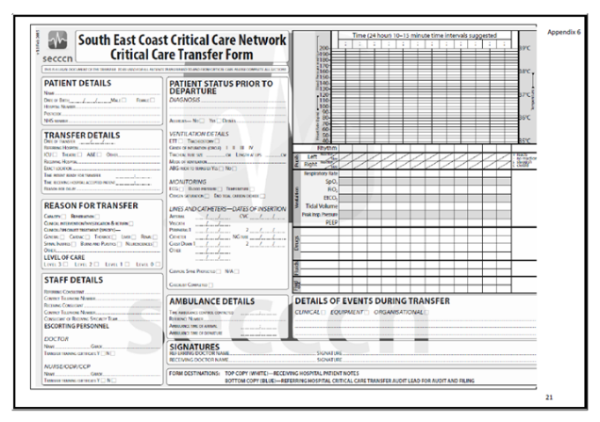

- The transfer form:
    - Medico-legal record of care during transit.
      - If it isn’t recorded – it wasn’t done.
    - Facilitates handover at receiving hospital.
    - Provides data for audit.

- WHAT TO DO WHEN THINGS GO WRONG

PREVENTION IS BETTER THAN CURE – ALWAYS THINK ABOUT THE WORST CASE SECNARIO AND HAVE A BACK-UP PLAN FOR WHEN THINGS GO WRONG!

The Journey – Summary
- Ensuring patient and staff safety is paramount.
- Know your contacts and how to get hold of them.
- Move the patient only when it is safe.
- Secure the patient and equipment.
- Remain seated and wear a safety belt.
- Keep a written record of events.
- Listen to the ambulance crew carefully.

The Ambulance Crashes
- Check yourself, colleagues and patient for injuries / deterioration.
- Call for help – 999
- Consider evacuation if fire or further collision is likely.
- Wear high visibility clothing outside vehicle.

Cardiac Arrest / Accidental Extubation
- Inform the ambulance crew and request to stop as soon as practical and safe.
- Assess need to access nearest ‘safe haven’, i.e. local or original A&E department.
- Proceed only when happy to do so.

The Batteries Have Run Out
- Be prepared:
    - Make sure pumps/monitors/ventilators are fully charged before use.
    - Keep dedicated transfer pumps, monitor.
    - Carry spare batteries/pumps if appropriate.

- Use the ambulance’s power source:
    - Connect equipment to the ambulance power supply using an inverter – but not before the ambulance has started its engine.

Someone is Being Sick!
- Prevention is better than cure – pick the escort team carefully and take appropriate medication pre-emptively.
- Ask ambulance crew to provide fresh air ventilation, consider facing forwards if possible.
- Know where the vomit bowls are.

Summary
- Accidents can happen.
- Restrict the potential for mishaps.
- Prepare for the problems:
    - Carry spare O₂ cylinder and a self-inflating bag.
    - Take high visibility clothing.
    - Call for help if required.
    - Speed of journey is dependent upon condition of patient and what ambulance crew feel is safe.
- Maintain good communication between all staff on vehicle.

- SPECIALIST TRANSFERS

Major Trauma
- Transfer of polytrauma patients is influenced by South West London & Surrey Trauma Network policies and pathways: (www.swlandstn.com)
- Secondary Transfer Protocol
- Isolated Head Injury Pathway
- Spinal Injury Transfer Pathway

Indications for transfer:
- Multi-system injury
- Severe head injury
- Spinal injury
- Cardiothoracic injury
- Burns
- Pelvic Injury

Transfer of major trauma patients from ED to MTC (St. George's Hospital):
- ED to ED Transfer
- Discuss with ED consultant on call 24/7 for advise on intermediate management
- ‘Time Critical Transfer’
- Notify ED at St. George’s when leaving the referring hospital

Head Injury
Referrals should be made to neurosurgery with:
- Persistent coma (GCS < 8) after initial resuscitation (evidence suggests better outcomes even if surgery is not required)
- Focal neurological deficit
- Compound depressed # / penetrating had injury
- New clinically significant abnormality on imaging
- Deteriorating GCS
- Seizure without full recovery
Follow head injury pathway from St. George’s Hospital (Appendix 4)

Note: Decrease in GCS by 2 or more is suggestive of serious deterioration and constitutes a neurosurgical emergency.

Transfer:
- High quality transfer improves outcome
- Resuscitation & stabilisation prior to transfer
  - GCS < 8 should be intubated and ventilated
- Aim for a maximum of 4 hours from injury to surgery
- Avoid secondary brain injury:
    - MAP > 90 mmHg
    - PaO2 > 13 kPa
    - PaCO2 4.5-5.0 kPa
    - If the patient is ventilated, use muscle relaxation with appropriate short acting sedation and analgesia
    - Glucose & Temperature manangement
- Involve the family members as much as practically possible

Transport Options:
- Patients who have intra-cranial air (pneumoncephalus) or have had a craniotomy should not fly before the 7th post-operative day unless in aircraft pressurised to altitude of surgery.
- Similar precautions should be taken with CSF leakage, penetrating head injury, air encephalogram/ventriculogram investigations.

Associated Injuries:
- Cervical spine protection should be taken if positive history and/or clinical concern, as up to 15% of spinal fractures are missed on first x-ray.
- Facial Injuries – treat as if basal skull # until excluded.
- External fixation of jaws – ensure quick release device/wire cutters available.
- Subarachnoid haemorrhage – re-bleed common, transfer before 48hrs or after 2 weeks.

Spinal Injuries (See Appendix 5)
- Referral to spinal unit:
    - Acute spinal cord injury
    - Cauda equina
    - Not a fracture without cord injury
- Issues dependant on level of injury and degree of spinal cord involvement.

Burns
London & South East of England Burns Network Criteria for Transfer to Specialist Unit:
- > 3% Superficial partial thickness (SPT), deep dermal (DD) or full thickness (FT) burns:
    - NAI
    - All burns not healed within 2 weeks
- Inhalation injury
- Facial/Hands and feet/genitalia and perineum/overlying major joints.
- All electrical burns
- All chemical burns.
- Other factors such as pre-existing illness, trauma, emotional or rehabilitative problems.
    - (Also see http://www.britishburnassociation.org/downloads National_Burn_Care_Referral_Guidance_-_5.2.12.pdf)

Burns Considerations:
- Early intubation (ET tubes should be left uncut as the degree of swelling can be substantial)
- Wash burn area and cover with cling film
- Analgesia
- Consider/assess for other injuries
- Burns patients have poor temperature control. Monitor temperature and keep them warm
- There can be substantial insidious blood loss.

Intra-Aortic Balloon Pump (IABP) Counter pulsation
Cardiac patients are now transferred with IABP in situ for specific reasons:
- Accelerating angina – transfer for cardiothoracic surgery.
- Ischaemic/Idiopathic Cardiomyopathy – for transplantation.
- Emergency surgical repair of structural defects i.e. Mitral Valve defect.
- Haemodynamic instability during cardiac catheterisation.
- IABP dependant patient who has exhausted the resources of referring hospital.

Follow current network protocol for transferring these patients (Appendix 3)

Obstetric Patients
- Need to be aware of physiological changes in pregnancy and resuscitation issues.
- The risks of transfer need to be weighed against the benefits that can only be given by the specialist receiving unit
- Need medical escort skilled in resuscitation & critical care as well as knowledge of obstetrics.
- In less acutely sick patients a midwife may be sufficient.
- If known foetal problems and early gestation a neonatal paediatrician should accompany.
- Transfer should take place before delivery where possible as this is the best option for the foetus.
- Doppler should be available for monitoring of baby en-route.
- The cardiovascular changes of pregnancy allow for pregnant women to lose up to 1500ml of blood without signs of shock although the foetus may be adversely affected already.
- After 20 weeks consider left lateral tilt to minimise the risks of aorto-caval compression.

Paediatrics
- Most are collected by retrieval teams as the specialist skills and equipment not available in all trusts.
- If polytrauma should go to MTC and not referred to retrieval team
- The retrieval team for South East Coast is the South Thames Retrieval Service (STRS).
- Head injuries are the exception to rule as time may be of the essence.
- If retrieval is not possible, try to ensure that paediatric trained/experienced staff with resuscitation and critical care skills accompany patient if at all possible.

Further detailed information for paediatric stabilisation and emergency neurosurgical transfer can be found on the South Thames Retrieval Service website: www.strs.nhs.uk

Summary
- All transfers regardless of reason follow the same lines of good practice and standards.
- If in doubt seek advice from referral hospital for specialist care during transfer.
- May need to request specific drugs/monitoring/transport options.

- REFERENCES
- Intensive Care Society
1997: Guidelines for the transport of the critically ill adult.
2002: Guidelines for the transport of the critically ill adult (updated).
2011: Guidelines for the transport of the critically ill adult (3rd Edition 2011)
- Department of Health 2000: Comprehensive Critical Care
- Association of Anaesthetists of Great Britain & Ireland (AAGBI) Safety Guideline—Interhospital Transfer February 2009.
http://www.aagbi.org/sites/default/files/interhospital09.pdf
- http://www.strs.nhs.uk/educationandguidelines/guidelines.aspx
- http://www.britishburnassociation.org/referral-guidance
- http://ceaccp.oxfordjournals.org/content/9/1/24.full
- www.swlandstn.com
- https://www.networks.nhs.uk/nhs-networks/south-east-coast-critical-care-network/transfers/policies-and-guidelines

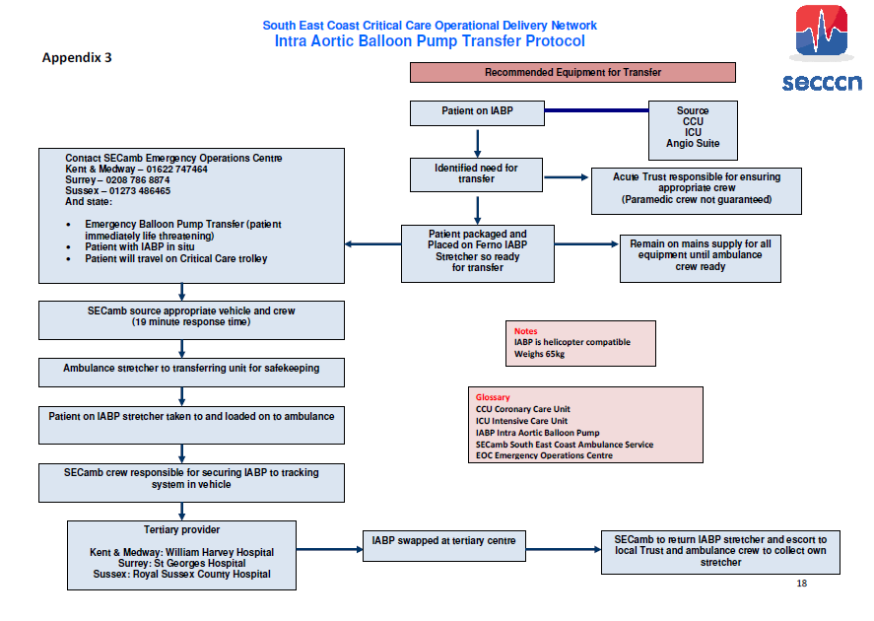

Appendix 4.

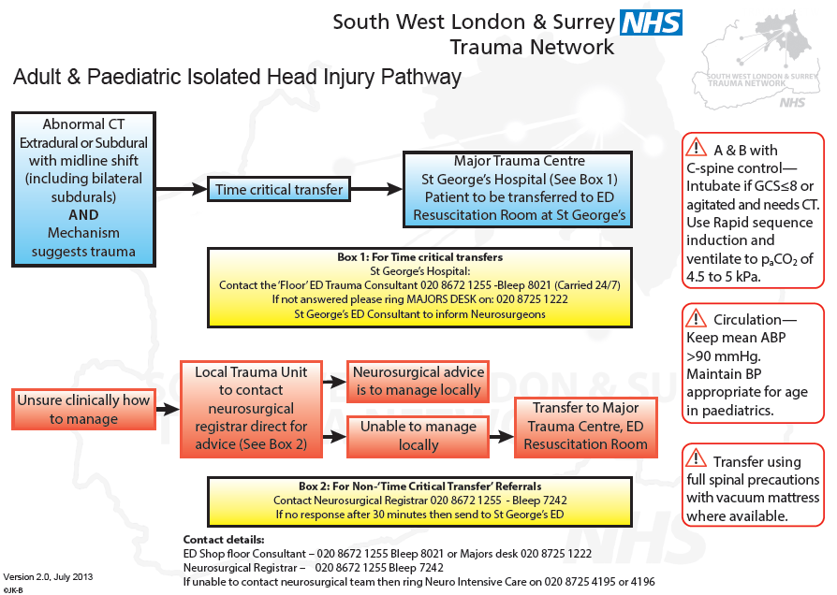

Appendix 5.

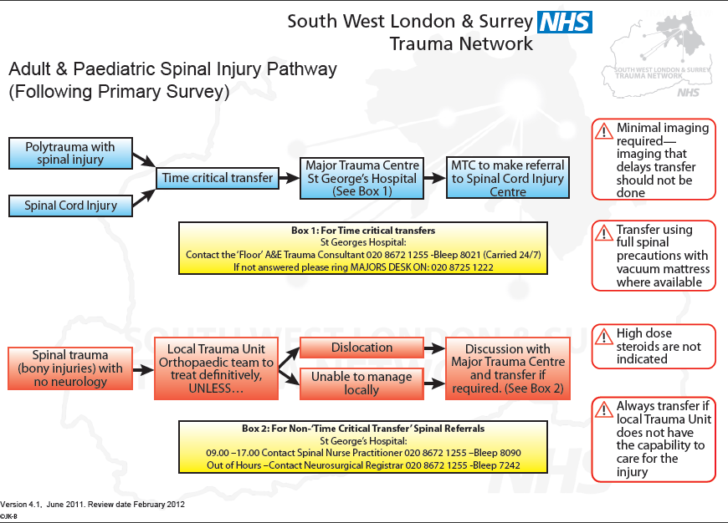

Appendix 6.

Appendix 7.

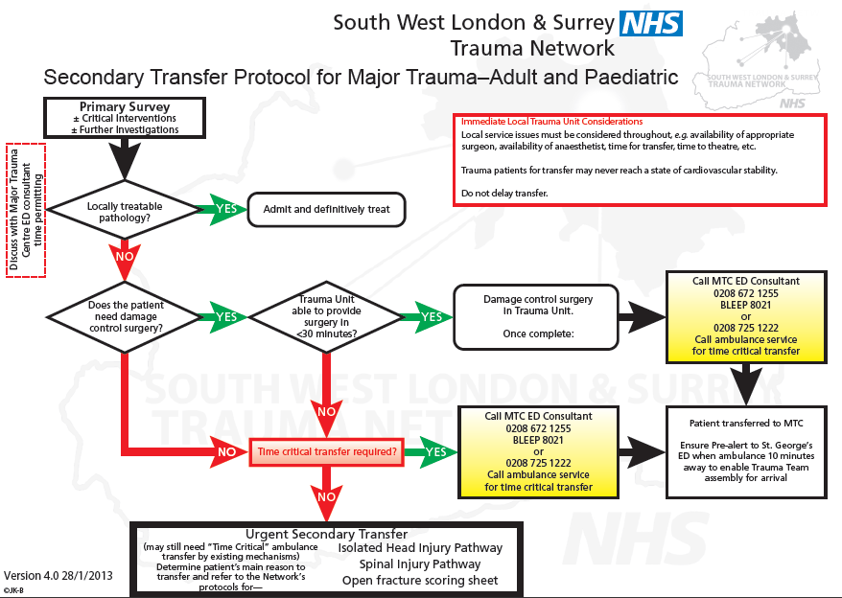

Appendix 8.

