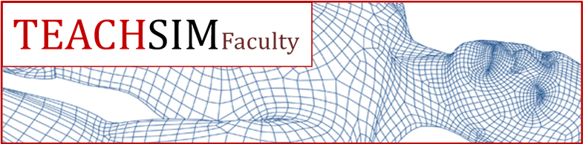

Training in Educational Approaches Course for Healthcare Simulation Faculty

FORM B: Simulation Practical Part 2 Signoff Level I certification:

- Completion of a LEVEL II “CONQUERING THE DEBRIEF” day course

- Evidence of attendance at a local simulation centre (own hospital or designated local centre) as a member of faculty for 3 SEPARATE simulation SESSIONS WITHIN 6 MONTHS of attending the level II day course.

PERSONAL DETAILS

Full Name:

Preferred first name:

(This will appear on your name badge)

GMC / Professional
Registration Number:

Address:

Contact number:

Email Address:

LEVEL 2 COURSE INFORMATION

Date course attended:

Location:

SIGN OFF: FACULTY MEMBER AT 3 DIFFERENT SIMULATION SESSIONS

DATE | SIMULATION | SESSION OUTLINE (Target | SIGNATURE
 | CENTRE | audience, learning | SIMULATION
 |  | objectives) | MANAGER /
 |  |  | SIMULATION
 |  |  | LEAD FOR
 |  |  | CENTRE
 |  |  | Name:
 |  |  | Post:
 |  |  | Signature:
DATE | SIMULATION | SESSION OUTLINE (Target | SIGNATURE
 | CENTRE | audience, learning | SIMULATION
 |  | objectives) | MANAGER /
 |  |  | SIMULATION
 |  |  | LEAD FOR
 |  |  | CENTRE
 |  |  | Name:
 |  |  | Post:
 |  |  | Signature:
DATE | SIMULATION | SESSION OUTLINE (Target | SIGNATURE
 | CENTRE | audience, learning | SIMULATION
 |  | objectives) | MANAGER /
 |  |  | SIMULATION
 |  |  | LEAD FOR
 |  |  | CENTRE
 |  |  | Name:
 |  |  | Post:
 |  |  | Signature:

Reflection on sessions (Max 500 words):

Please return your completed form to:

Holly Davies

TEACHSimFaculty Coordinator

Education Centre
Royal Surrey County Hospital
Egerton Road

Guildford
Surrey
GU2 7XX
Tel 01483 571 122 ext 4388
Fax 01483 303691

Email Rschteachsimfaculty@gmail.com

You will be sent your Level 2 certificate in 2 weeks of receipt.

